# Viewing vehicle and installation status with Help Desk

The Help Desk reports a vehicle’s information and health status, including:

* The vehicle’s make and model,
* The vehicle’s latest hardware and software versions,
* The vehicle’s software update history.

The Help Desk also reports installation failures across all vehicles in the system.

To view your vehicle’s details and health status:

1. Log in to the Admin Portal as a user with permission to view the Help Desk.
2. Click **Help Desk** in the upper-right corner of the portal.
3. Enter your vehicle’s identification number (‘VIN’) and click **Search**.

The Help Desk loads your vehicle’s model details and software installation history.

## Vehicle details

The Help Desk first lists your vehicle’s make, model, trim (ex: ‘DX’), year, and VIN:

Screen print of the Help Desk highlighting the given VIN’s make, model, trim, year, and VIN.

The vehicle listed is a 2015 Mythos Apollo EX.

## Installed software

The Installed Software section reports the updatable components in your vehicle and their last-known software versions. The Help Desk prints the last hardware and software lineup that your vehicle reported:

Screen print of the Help Desk highlighting the given VIN’s last-reported hardware components with their last-reported software versions. 

This vehicle reports eight components: Analytics, SimpleScan, Arity-Analytics, aqLcdApp, BringGo, MYT ICM, MYT ECM, and Sensors.

In the example above, vehicle BC123DEF1FGFF3064 has eight updatable components.

### Viewing the status of all software updates

1. Log in to the Admin Portal as a user with permission to view the Help Desk.
2. Click **Help Desk** in the upper-right corner of the portal.
3. Enter your vehicle’s identification number (‘VIN’) and click **Search**.
4. In the Software Status section, click **All**.

The Help Desk lists your vehicle’s entire software update history, including:

* Successful installations,
* Pending installations that have not been processed yet,
* Failed installations.

The following example shows a vehicle that has reported two successful updates to its BringGo application, both on February 18, 2018:

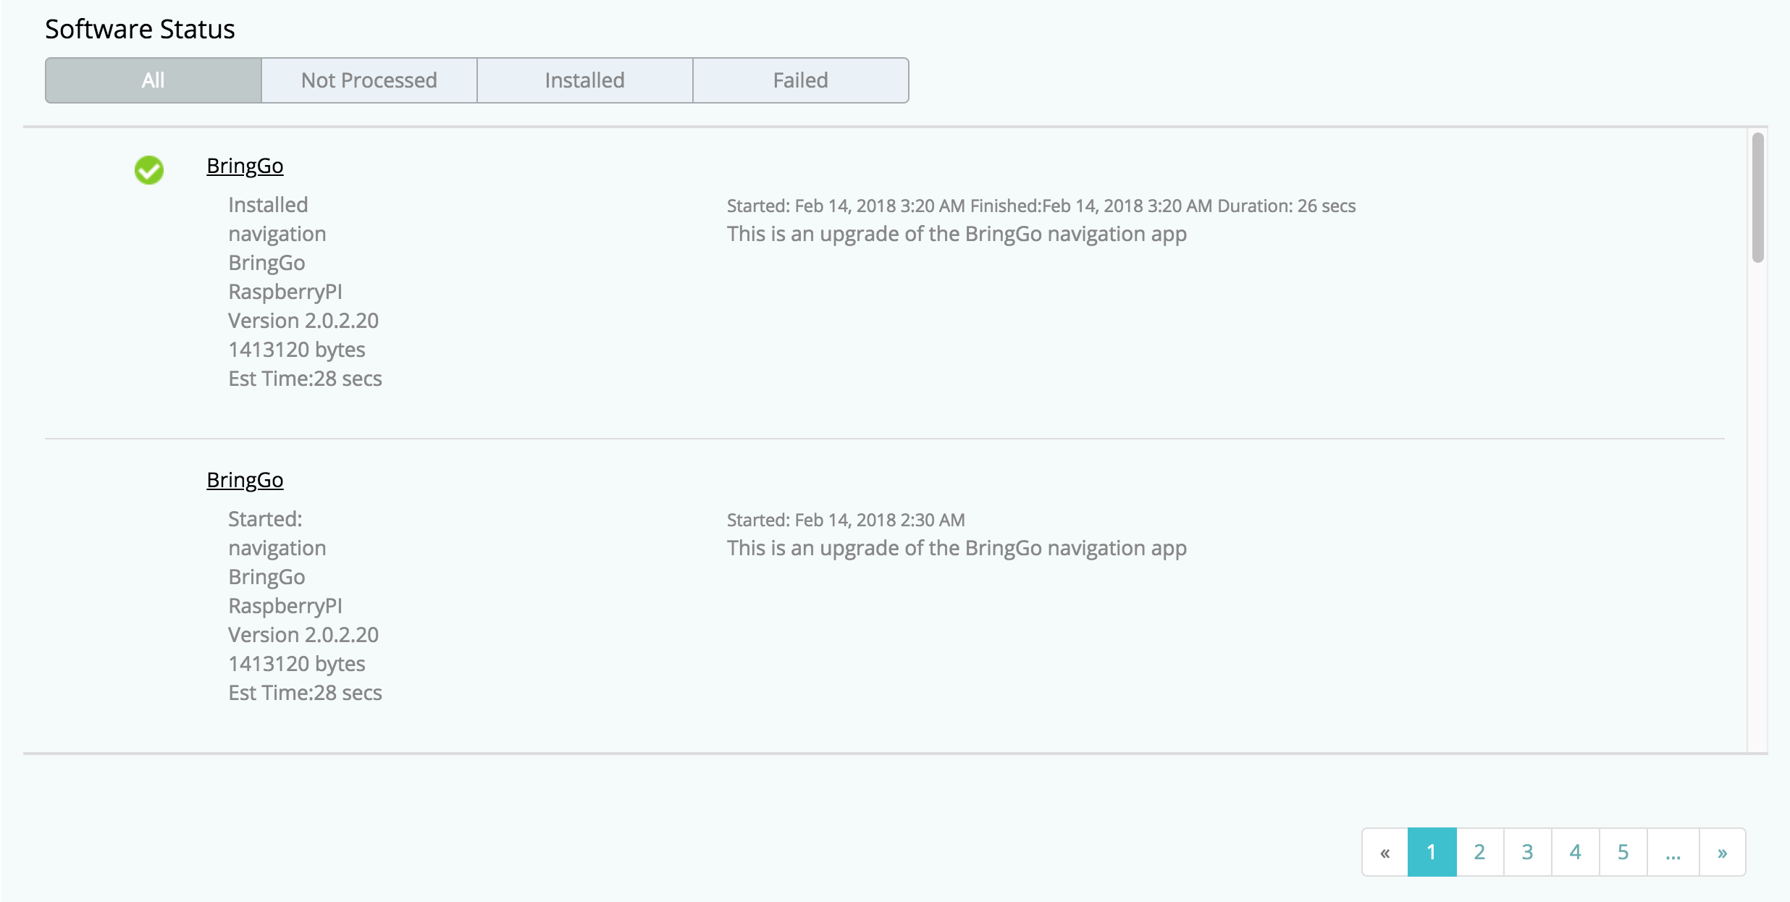

### Viewing pending installations

1. Log in to the Admin Portal as a user with permission to view the Help Desk.
2. Click **Help Desk** in the upper-right corner of the portal.
3. Enter your vehicle’s identification number (‘VIN’) and click **Search**.
4. In the Software Status section, click **Not Processed**.

The Help Desk lists only updates that are scheduled, but have not been completed yet.

The following example shows that the vehicle has updates pending for its Arity-Analytics, Analytics, and BringGo components:

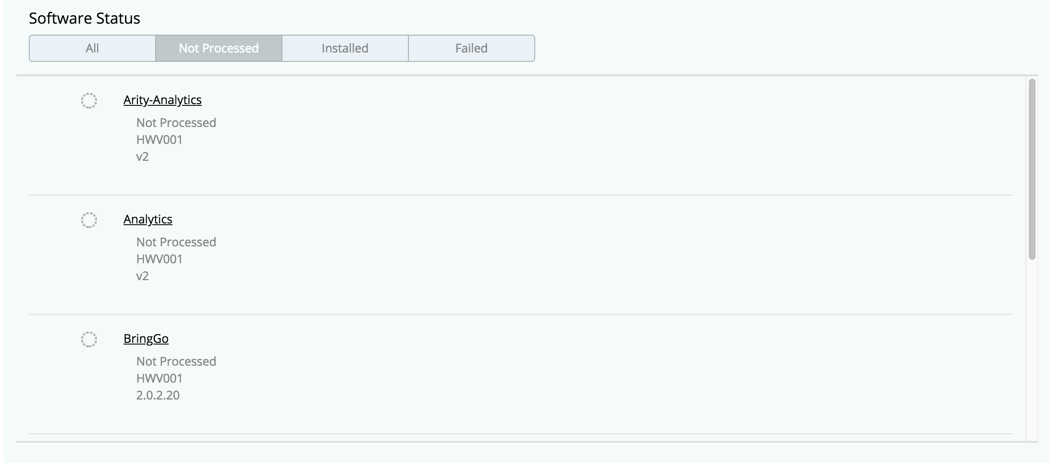

### Viewing successful installations

1. Log in to the Admin Portal as a user with permission to view the Help Desk.
2. Click **Help Desk** in the upper-right corner of the portal.
3. Enter your vehicle’s identification number (‘VIN’) and click **Search**.
4. In the Software Status section, click **Installed**.

The Help Desk lists only updates that have been installed successfully.

In the following example the vehicle reports successful installations for its Mythos Analytics and Engine Controller Performance components, both on February 14, 2018:

Screen print of the Help Desks ‘Installed’ tab. The vehicle reports successful installations for its Mythos Analytics and Engine Controller Performance components, both on February 14, 2018. 

In the following example the vehicle reports successful installations for its Mythos Analytics and Engine Controller Performance components, both on February 14, 2018: 

### Viewing failed installations

1. Log in to the Admin Portal as a user with permission to view the Help Desk.
2. Click **Help Desk** in the upper-right corner of the portal.
3. Enter your vehicle’s VIN and click **Search**.
4. In the Software Status section, click **Failed**.

The Help Desk lists only updates that have failed along with an error code.

The following example shows that on February 14, 2018 the vehicle attempted to install updates to its Gateway – Nigrogen and Engine Controller Performance components, but both installs failed with error code 321:

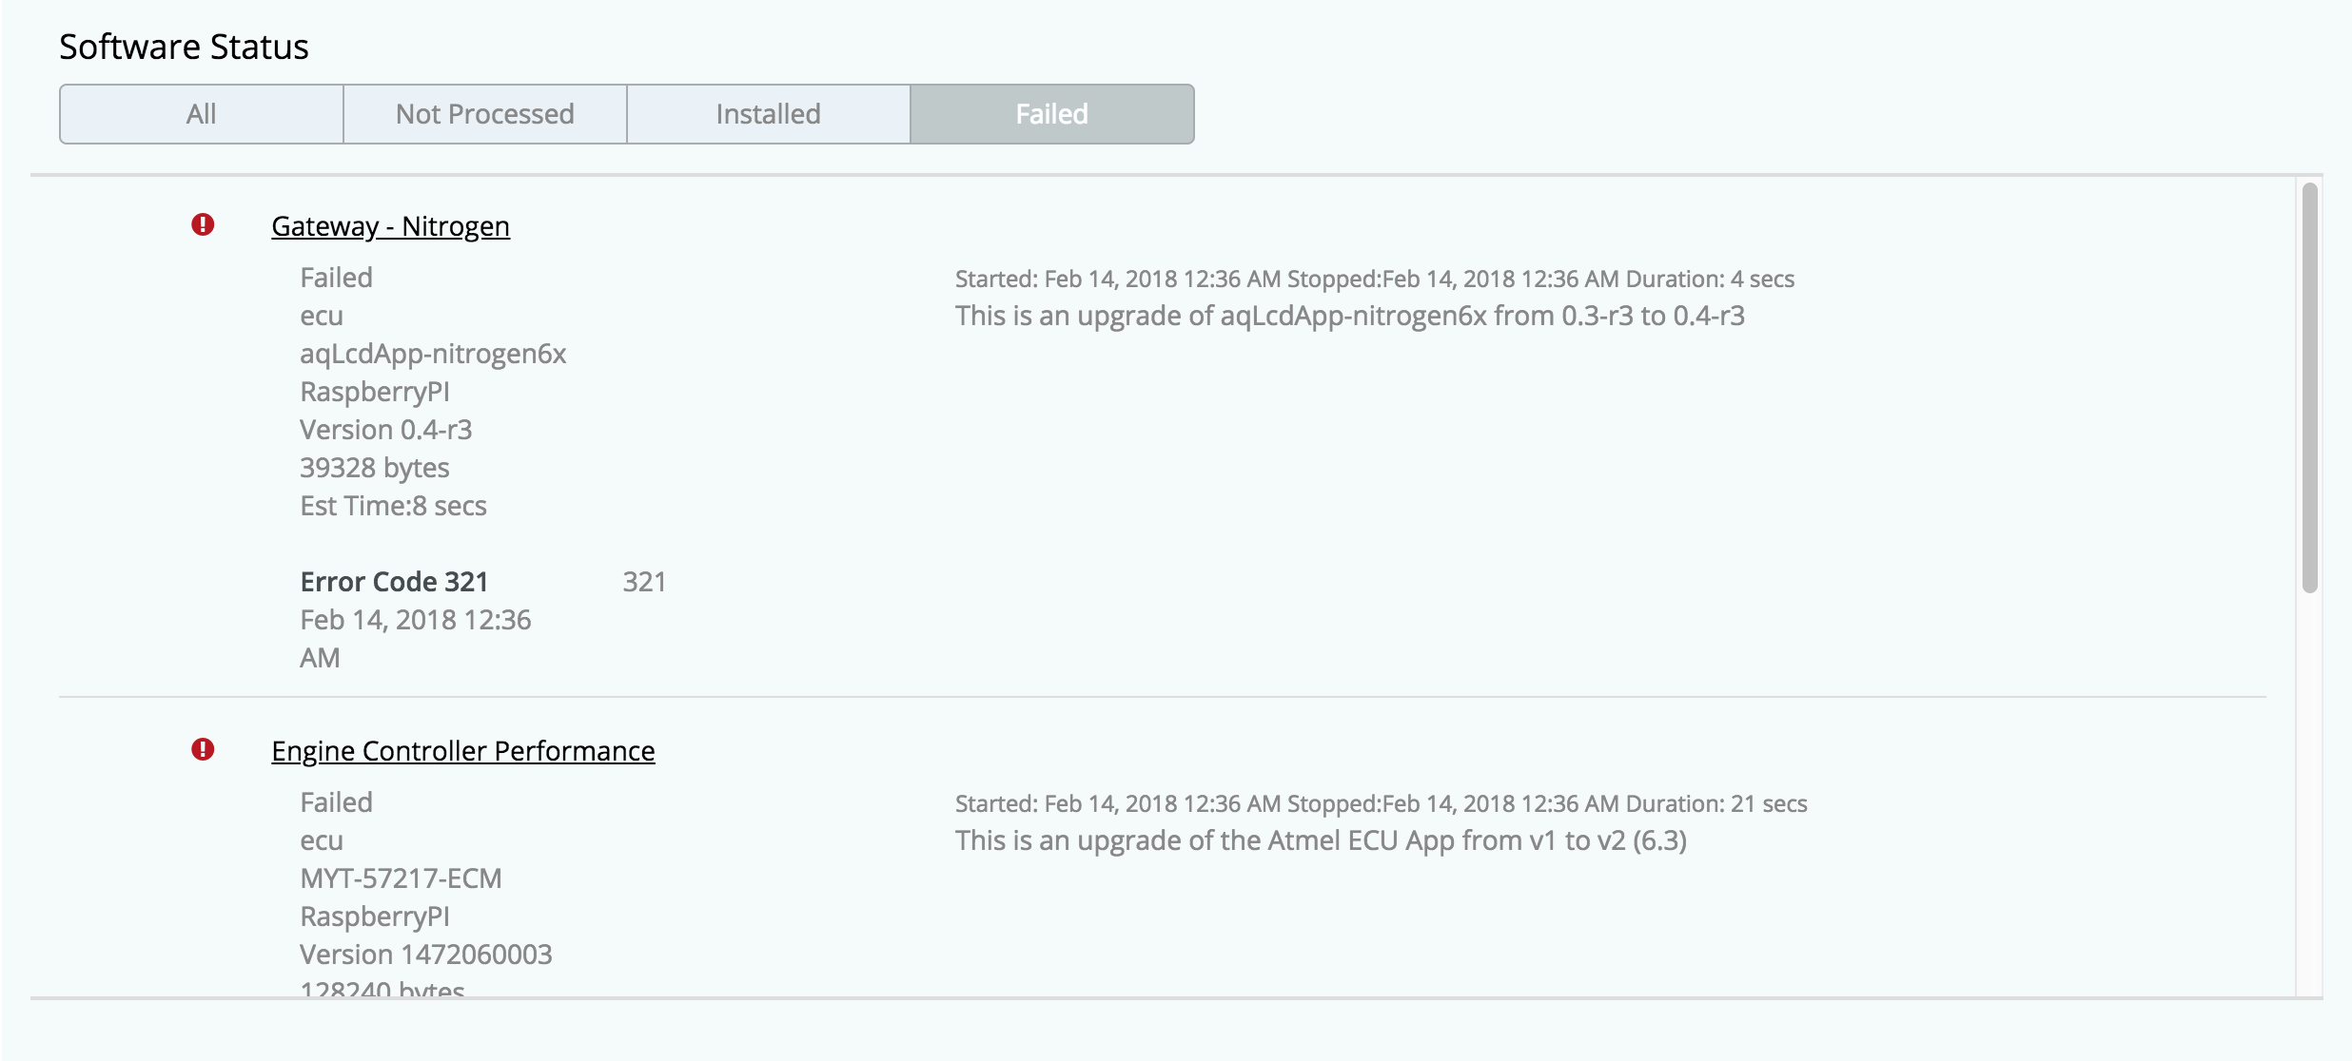

### Exporting a vehicle’s status and installation history

You can export your vehicle’s manufacturer’s details and software update history to a printable format:

1. Log in to the Admin Portal as a user with permission to view the Help Desk.
2. Click **Help Desk** in the upper-right corner of the portal.
3. Enter your vehicle’s identification number (‘VIN’) and click **Search**.
4. In Software Status, select the installation history you want to export: **All** events, **Not Processed** (pending), **Installed**, or **Failed**.
5. In the Software Status section, click **PDF Version**.

Help Desk exports the vehicle details, installed software versions, and the installation history for the software status that you selected.

Reviewing terms and conditions

The Help Desk reports each time that a driver in the fleet accepted the terms and conditions for the OTAmatic service:

1. Log in to the Admin Portal as a user with permission to view the Help Desk.
2. Click **Help Desk** in the upper-right corner of the portal.
3. Enter your vehicle’s identification number (‘VIN’) and click **Search**.
4. Scroll to the Terms and Conditions report near the bottom of the page.

In the following example the vehicle’s driver accepted the terms and conditions on February 13, 2018.

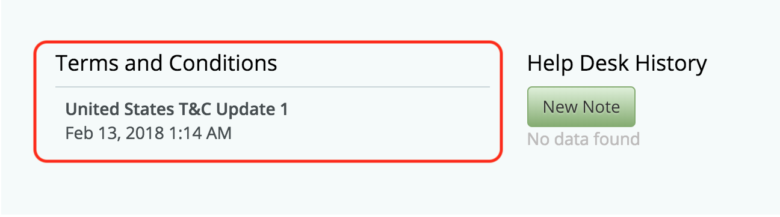

The terms and conditions for a vehicle are typically accepted only once when the driver signs up for the service; however, it is valid for a driver to accept the terms and conditions multiple times such as when they reinstall the phone application.

### Managing notes

Fleet managers can leave notes for each other in Help Desk. To add a note:

1. Log in to the Admin Portal as a user with permission to view the Help Desk.
2. Click **Help Desk** in the upper-right corner of the portal.
3. Enter your vehicle’s identification number (‘VIN’) and click **Search**.
4. Click **New Note**.
5. Write your note and click **Save**.

In the following example, the vehicle has one note logged on February 14, 2018 and reads ‘Please investigate the failed installations’:

